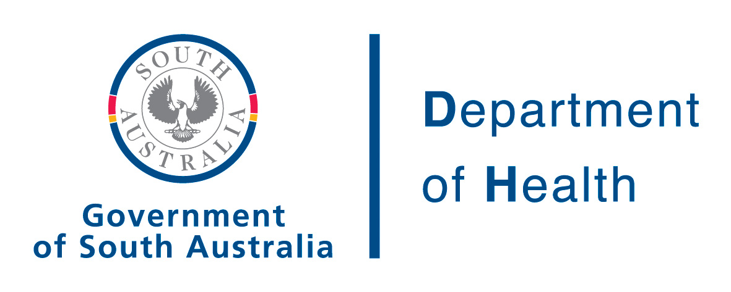

PROTOCOL - Prophylactic use of Rh D immunoglobulin (anti-D) in Obstetrics
(CSL Rh D immunoglobulin)

Indications | Rh D immunoglobulin is indicated for the prevention of Rh D sensitisation in Rh D negative women.
Contraindications | In the obstetric setting Rh D immunoglobulin should not be given to:  - An Rh D positive woman  - An Rh D negative woman with preformed anti-D antibodies  Note: Rh D immunoglobulin must not be given to the baby

Summary of current dosing recommendations for Rh D negative pregnant women

 | Dose of Rh D immunoglobulin
Obstetric conditions
Sensitising events up to and including the 12th week | 250 IU
Sensitising events after the 12th week of pregnancy | 625 IU
Sensitising events in multiple pregnancy | 625 IU
Pregnancy
Antenatal prophylaxis (at 28 and 34 weeks) | 625 IU
Postpartum
If the baby is NOT Rh D negative | 625 IU

General

For successful immunoprophylaxis, Rh D immunoglobulin should be administered as soon as possible after a sensitising event, but always within 72 hours. If Rh D immunoglobulin has not been offered within 72 hours, a dose given within up to 9-10 days may provide protection.

Rh D immunoglobulin should be given slowly by deep intramuscular injection, using a 20 gauge needle. If a large dose (more than 5 mL) is required, it is advisable to administer it in divided doses at different sites.

Rh D immunoglobulin is a blood product and the minimum requirement is for informed consent to be documented in the patient record.

Sensitising events in the first trimester (up to and including week 12 of gestation)

- A dose of 250 IU CSL Rh D immunoglobulin (minidose) should be offered to every Rh D negative woman with no preformed anti-D antibodies to ensure adequate protection against immunisation for the following indications:
- threatened miscarriage
- miscarriage
- termination of pregnancy
- ectopic pregnancy
- chorionic villus sampling
- If the gestational age is not known with certainty and the possibility exists that the gestational age is 13 weeks or more, then a larger dose [625 IU] should be given.
- If there is a multiple pregnancy administration of the larger dose [625 IU] is recommended.
- A dose of 250 IU Rh D immunoglobulin (minidose) is sufficient to prevent immunisation by fetomaternal haemorrhage [FMH] of 2.5 mL of fetal red cells (5 mL whole blood).

Sensitising events beyond the first trimester (after week 12 of gestation)

- A dose of 625 IU CSL Rh D immunoglobulin should be offered to every Rh D negative woman with no preformed anti-D antibodies to ensure adequate protection against immunisation for the following indications:
- genetic studies (chorionic villus sampling, amniocentesis and cordocentesis)
- abdominal trauma considered sufficient to cause fetomaternal haemorrhage [FMH]
- each occasion of revealed or concealed antepartum haemorrhage (when a woman suffers unexplained uterine pain, the possibility of concealed antepartum haemorrhage and the need for immunoprophylaxis should be considered)
- external cephalic version (performed or attempted)
- miscarriage or termination of pregnancy
- intrauterine death

- Evidence for the efficacy of this dose for these indications is not available. It is, therefore, recommended that the magnitude of fetomaternal haemorrhage [FMH] be assessed, when there is a likelihood of a significant FMH, such as severe abdominal trauma, abruption, transplacental puncture or puncture of fetal blood vessels. Further doses of Rh D immunoglobulin need to be administered for FMH in excess of 6 mL fetal red blood cells (12 mL fetal blood).

Antenatal Prophylaxis (at weeks 28 and 34 of gestation)

- Universal prophylaxis, at 28 and 34 weeks gestation, with Rh D immunoglobulin to Rh D negative women with no preformed anti-D antibodies is generally regarded as best practice.

- Rh D immunoglobulin, in the form of 625 IU CSL Rh D immunoglobulin, should be offered at 28 weeks and again at 34 weeks, to all Rh D negative women who have no preformed anti-D antibodies.

- Unless the woman has received Rh D immunoglobulin for a sensitising event within the last 6 weeks, antibody screening should be repeated before giving the Rh D immunoprophylaxis at 28 weeks, but not at 34 weeks. The test result does not need to be available before giving the Rh D immunoglobulin.

Postpartum

- A dose of 625 IU CSL Rh D immunoglobulin should be offered to every Rh D negative woman giving birth except when the baby is Rh D negative.
- Rh D immunoglobulin should not be given to women with pre-existing anti-D antibodies, except where this is known to be due to the presence of antenatally administered Rh D immunoglobulin.
- If it is unclear whether the anti-D detected in the mother’s blood is passive or preformed, the treating clinician should be consulted. If there is continuing doubt, Rh D immunoglobulin should be administered.
- The magnitude of fetomaternal haemorrhage [FMH] should be assessed by a method capable of quantifying a haemorrhage of > 6 mL of fetal red cells (12 mL of whole blood). The recommended method for this is flow cytometry. For FMHs of 6 mL red cells or greater, further doses should be administered sufficient to prevent maternal immunisation.
- A dose of 625 IU will protect against a fetomaternal haemorrhage of up to 6 mL of Rh D positive red blood cells (12 mL of whole blood). For haemorrhages greater than 6 mL, the recommended dose is 100 IU per extra mL Rh D positive red blood cells in excess of 6 mL (i.e 50 IU per mL of whole fetal blood in excess of 12 mL whole blood).

References and further information:

Current product information sheet(s)

National Blood Authority. "Guidelines on the prophylactic use of Rh D immunoglobulin (anti-D) in obstetrics". 2003.

NHMRC. "Guidelines (1999) for the use of RhD Immunoglobulin in Obstetrics" http://www.health.gov.au/nhmrc/

Directive from Chief Medical Officer, Commonwealth of Australia to Product User RhD Immunoglobulin (anti-D) in Obstetrics – 4.11.02

Transfusion Medicine Manual 2003- Australian Red Cross Blood Service

Websites: www.anzsbt.org.au
www.ranzcog.edu.au
www.arcbs.redcross.org.au
www.csl.com.au

Issued by: Health System Performance
Health System Management
Department of Health

Contact: Deb Brooking
Manager, Service Innovation
Phone: 8226 6657

